CLASS OF 2020 ONLY!

PAYING FOR CBC DUAL CREDIT CLASSES – GWHS DEADLINES:
Summer I – by May 24, 2019
Summer II – by June 18, 2019
Fall 2019 – by August 8, 2019
Spring 2020 – by January 8, 2020

OPTION 1: Online payments through Cougar Den
- Go to CBC Website: www.coastalbend.edu
- Top right corner, click on “Cougar Den”
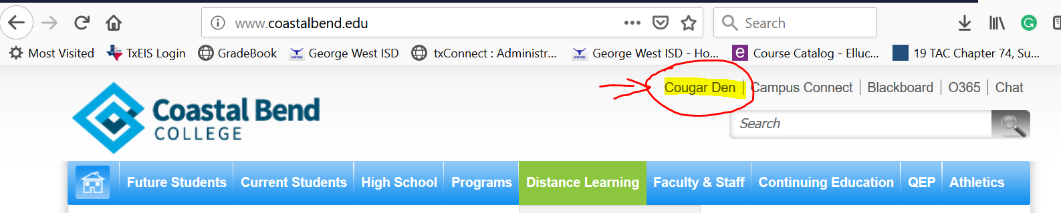
- A new window will open – login to student’s “Cougar Den” account
  - Username and Password for Cougar den (If you have issues logging in, you will need to contact CBC directly.)
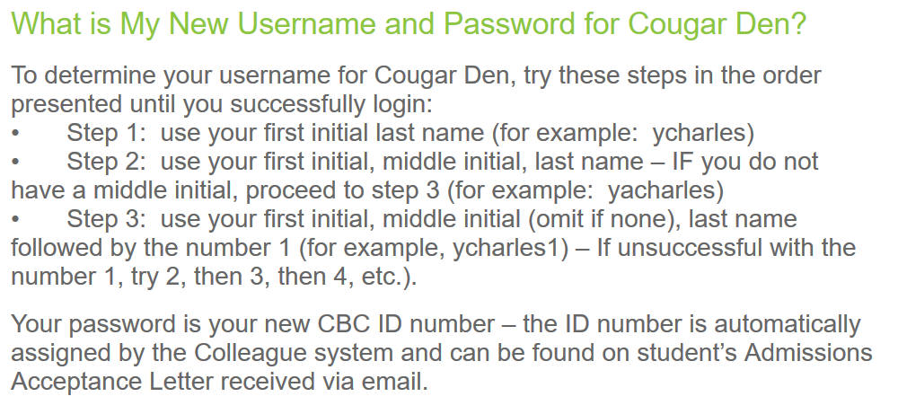

- Once the account is open, you will select “Student Self-Service” under Campus Applications
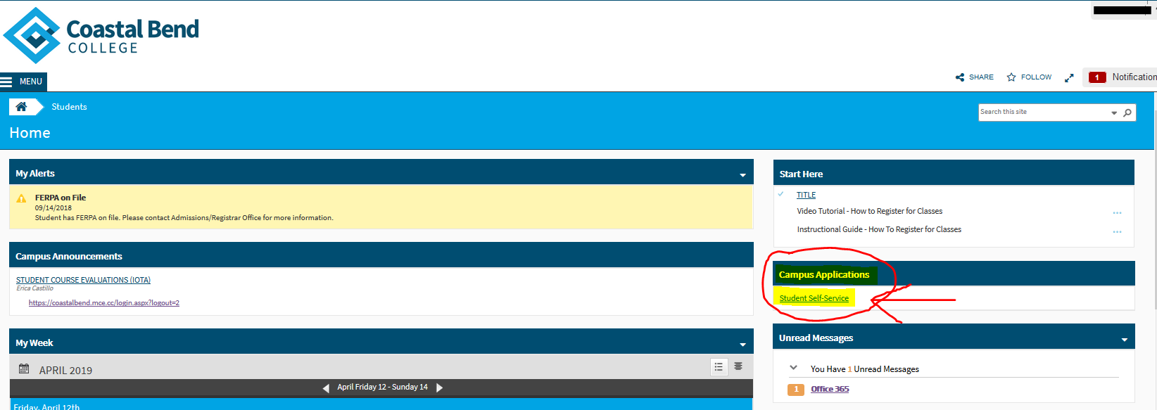
- Select “Student Finance”
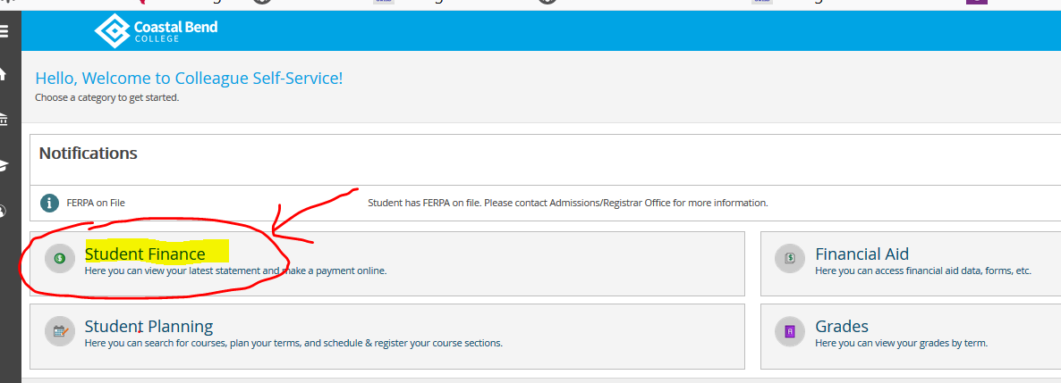
- You can select the term to verify you are enrolled in the correct courses
- Then you will select “Make a payment”
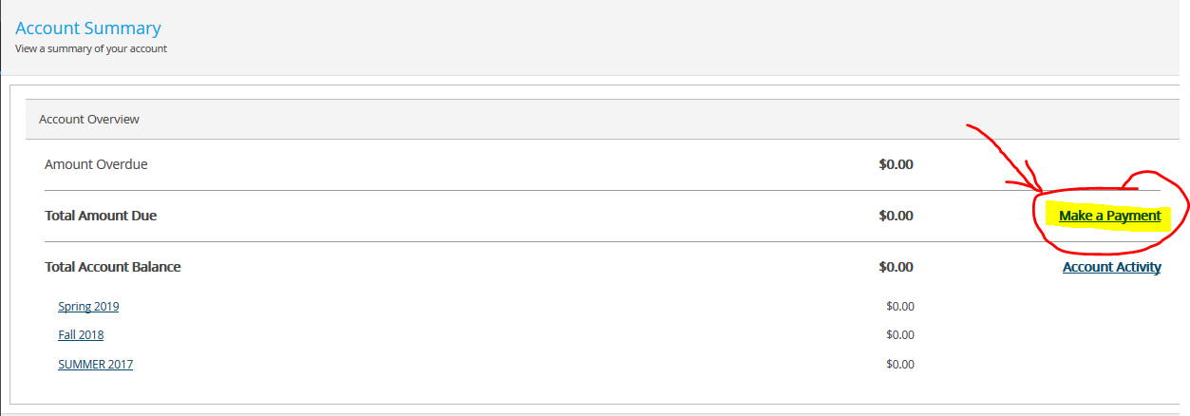

- A message will appear that is letting you know you will be moving to a secure Payment Center – select “Continue to Payment Center”
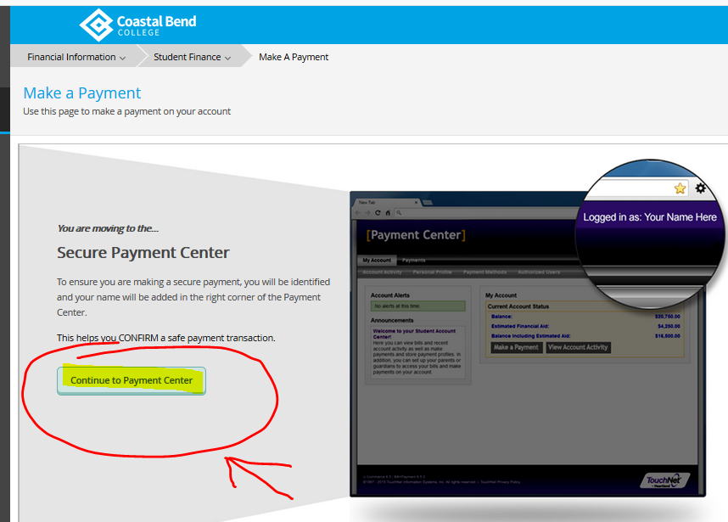
- A new window will open where you will be able to make a payment. Continue following the instructions to complete the payment.

OPTION 2: Payments over the phone with a credit card
Call one of the following numbers to speak to the CBC business office. If you are unable to contact someone at the Beeville campus, any other CBC campus can take your payment (Alice or Pleasanton). Have the student’s CBC ID number available!

361.354.2223 361.664.2981 x 3043 (Alice)
361.354.2213 830.569.4222 x 1201 (Pleasanton)
361.354.2220

OPTION 3: Pay CBC directly
Go directly to the CBC to the business office on Charco Road to make a payment using a check, cash, or credit card (payments can also be made at the Alice or Pleasanton campuses). Have the student’s CBC ID number available!

